APP DEVELOPMENT

Statistics supporting app development:

More of the population has food allergies than ever before and around the world, hospitals are seeing the largest amounts of cases in history. One large-scale review of hospital admissions data found that anaphylaxis cases are consistently rising in the US, Australia and Europe, and other regions. The results are in the following graph. - https://www.bbc.com/future/article/20201023-food-allergies-why-nut-dairy-and-food-allergy-are-rising
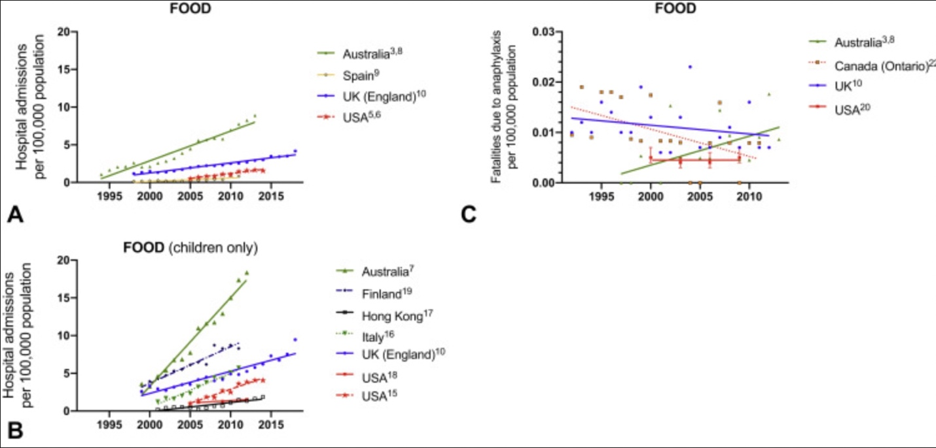
Figure: A) Anaphylaxis in adults and children caused by food allergies; B) Anaphylaxis in children caused by food allergies; C) Fatalities caused by food-induced anaphylaxis

- In the US, hospital visits for food allergies increased threefold from 1993 to 2006 and the prevalence of reported food allergy increased 18% from 1997 through 2007.- https://pubmed.ncbi.nlm.nih.gov/19917585/

- Research done by The Natasha Allergy Research Foundation concluded that between 2013 and 2019, the number of cases of children hospitalized with severe allergic reactions in England has increased by 72 per cent over the last six years, from 1,015 admissions to 1,746.- https://www.narf.org.uk/blog/new-nhs-digital-figures-reveal-huge-rise-in-children-hospitalised-with-severe-allergic-reactions

- Kari Nadeau, an allergy specialist at Stanford University, explains that the rate of food allergies worldwide has increased from around 3% of the population in 1960 to around 7% in 2018. This fact was explored through the prospect of the overall growing of all allergies around the world, including the vast increase of peanut allergies shown in the below graph- https://www.bbc.com/future/article/20201023-food-allergies-why-nut-dairy-and-food-allergy-are-rising

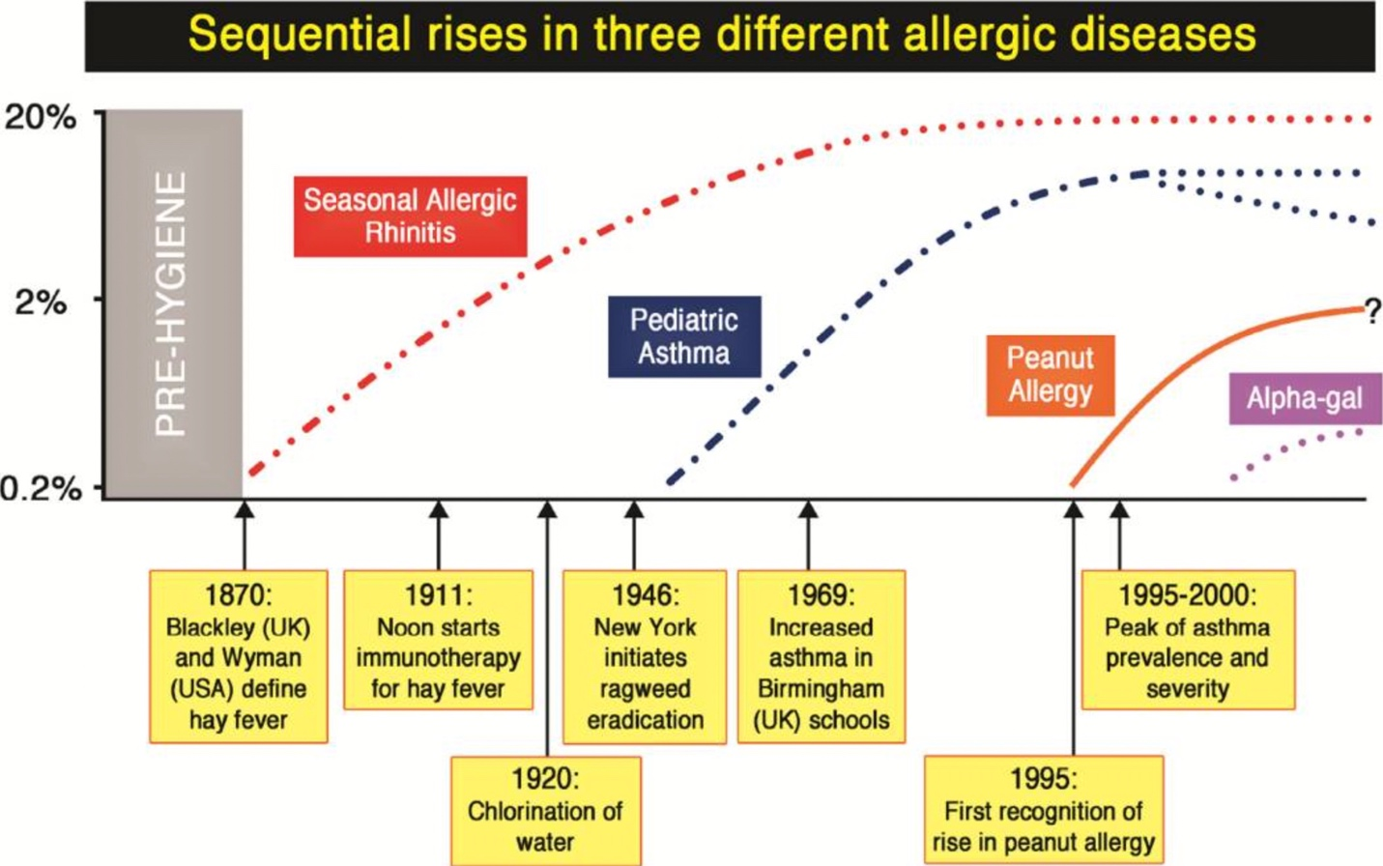
- https://www.ncbi.nlm.nih.gov/pmc/articles/PMC4617537/

Bibliography:
https://www.bbc.com/future/article/20201023-food-allergies-why-nut-dairy-and-food-allergy-are-rising
https://www.narf.org.uk/blog/new-nhs-digital-figures-reveal-huge-rise-in-children-hospitalised-with-severe-allergic-reactions
https://pubmed.ncbi.nlm.nih.gov/19917585/
https://www.ncbi.nlm.nih.gov/pmc/articles/PMC4617537/

